Crear Single-SPA angular

<https://single-spa.js.org/docs/create-single-spa/>

create-single-spa

Single-spa offers a CLI for those who prefer autogenerated and managed configurations for webpack, babel, jest, etc. You do not have to use the CLI in order to use single-spa.

The CLI is called create-single-spa (Github link). It is primarily intended for the creation of new projects, but may also be useful for migrating existing projects (especially migrating CRA or frameworkless projects).

npm install --global create-single-spa

create-single-spa

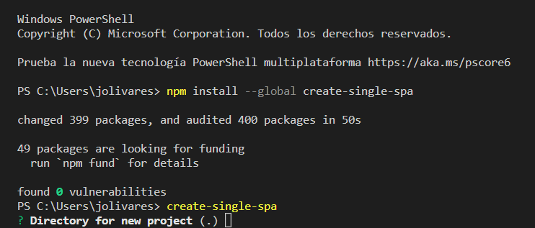

? Directory for new project .: **Enter (vacio)**

? Select type to generate (Use arrow keys)

**> single-spa application / parcel**

in-browser utility module (styleguide, api cache, etc)

single-spa root config

? Which framework do you want to use?

react

vue

**> angular**

svelte

other

? Project name (can use letters, numbers, dash or underscore): **mfe-prueba**

? Would you like to add Angular routing? (y/N): **y**

? Which stylesheet format would you like to use? (Use arrow keys)

**> CSS**

SCSS [ https://sass-lang.com/documentation/syntax#scss ]

Sass [ https://sass-lang.com/documentation/syntax#the-indented-syntax ]

Less [ http://lesscss.org

? Would you like to share anonymous usage data about this project with the Angular Team at

Google under Google’s Privacy Policy at https://policies.google.com/privacy? For more

details and how to change this setting, see https://angular.io/analytics. (y/N): **y**

The package single-spa-angular@6.3.1 will be installed and executed.

Would you like to proceed? (Y/n): **y**

? Does your application use Angular routing?: **y**

? What port should your project run on?: **4200**

Configuraciones:

